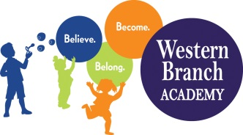 | WBA 2019-2020  PK 2 School Supply List  Teachers may request additional items at a later date

Supplies that need to be labeled:
Tote Bag/Children’s Backpack
Lunchbox (daily)
Pull-Ups (If Applicable)
Extra set of clothes (Including socks & underwear)
1 Folder With Pockets
1 White 1 inch binder – for new students only
Nap Mat – for full-day students only
Crib Sheet – for full-day students only
Blanket – for full-day students only

Supplies that do not need to be labeled:
1 pack of page protectors
4 Packages of Baby Wipes
2 Boxes of Tissues
4 Packs of 5oz Cups
1 Family Photo
2 Photos of Child (Wallet Size)
1 Container Lysol Wipes
1 Package Watercolors
1 4-Pack of Play-Doh
10 Glue Sticks
1 Box of Crayons (24 Count)
1 Box Broad Line Washable Markers
2 Boxes Quart Ziploc Bags
2 Boxes Gallon Ziploc Bags

