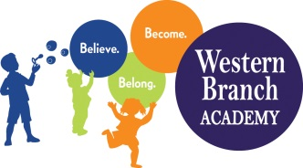 | WBA 2019-2020  PK 3 School Supply List  Teachers may request additional items at a later date

Supplies that need to be labeled:
Tote Bag/Children’s Backpack
Lunchbox (daily)
Pull-Ups (If Applicable)
Extra set of clothes (Including socks & underwear)
1 Folder With Pockets
1 White 1 Inch Binder – for new students only
Nap Mat – for full-day students only
Crib Sheet – for full-day students only
Blanket – for full-day students only

Supplies that do not need to be labeled:
1 pack of Page Protectors
3 Packages of Baby Wipes
2 Boxes of Tissues
4 Packs of 5oz Cups
1 Box Broad Line Washable Markers
1 Package Dry-erase Markers (fine-tip)
1 Family Photo
2 Photos of Child (Wallet Size)
1 Container Lysol Wipes
1 Package Watercolors
1 Box Fine Tip Washable Markers
1 4-Pack of Play-Doh
6 Glue Sticks
Girls-
1 Box of Colored Pencils
2 Boxes Quart Ziploc Bags
1 Package Fine Line Washable Markers
Boys –
1 Box of Crayons (24 count)
1 Package Colored Pencils
2 Boxes Gallon Ziploc Bags

