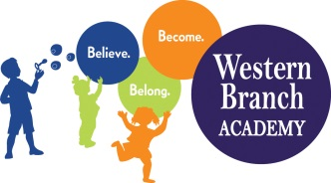 | WBA 2019-2020  Kindergarten Supply List  Teachers may request additional items

Supplies That Need to Be Labeled:
Backpack/Lunchbox
Extra Set of Clothes
1 Pencil Pouch (Soft, with Zipper)
1 Composition Notebook
1 Pair Fiskars Scissors
1 Folder with Pockets

Supplies That Do Not Need to Be Labeled:
2 Boxes Crayola Crayons (24 Count)
1 Box Crayola Colored Pencils
2 Boxes Broad Line Crayola Washable Markers
2 Boxes Fine Line Crayola Washable Markers
1 Package Expo Brand Dry Erase Markers (Chisel Tip or Fine Tip)
1 Package of Pencils
12 Glue Sticks (White)
1 Bottle Elmer’s School Glue
1 Package Index Cards
2 Packages Baby Wipes
1 Box of Tissues
2 Containers Clorox Wipes
1 Box Quart Size Ziploc Bags (Girls)
1 Box Gallon Size Ziploc Bags (Boys)
4 Packages 5oz Cups
1 Family Picture
1 Individual Picture

