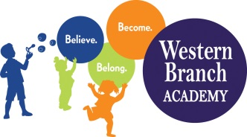 | WBA 2022-2023  Kindergarten Supply List  Teachers may request additional items
Supplies That Need to Be Labeled:
Backpack/Lunchbox
Extra Set of Clothes
1 Hard Pencil Box
1 Primary Composition Notebook
1 Pair Fiskars Scissors (blunt tip)
1 Folder with pockets
2 Boxes of Fine Tip Washable Markers
2 Boxes of Broad Line Washable Markers
2 Boxes of Crayons (24 count)
1 4-pack of Play-Doh
1 Pack of Colored 3X5 Index Cards
5 packages of water colors

Supplies That Do Not Need to Be Labeled:
1 Package Dry Erase Markers (Fine tip)
1 Box Crayola Colored Pencils
1 Package of Pencils
2 Packages Baby Wipes
2 Boxes of Tissues
2 Containers Clorox Wipes/Lysol spray (when possible)
1 Box Quart Size Ziploc Bags
1 Box Gallon Size Ziploc Bags
4 Packages 5oz. Cups
1 Family Picture
1 Individual Picture
Old T-Shirt for Art/Painting

