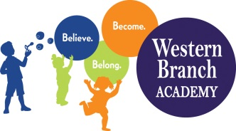 | WBA 2022-2023  PK 2 School Supply List  Teachers may request additional items

Backpack (Large enough to fit a folder)
Extra Set of Clothes (Please Label All Items with Child’s Name)
Lunch Box (Bring Daily)
Diapers/Pull-ups if needed (Ongoing Throughout the Year)
2 Packs of Baby Wipes
1 Box of Tissues
4 pkgs. 5 oz. Cups
1 Folder with Pockets (Labeled)
1 Box Gallon Ziploc Bags
1 Box Quart Ziploc Bags
2 Packs of Glue Sticks
1 Pack of Black Sharpies
1 Box of Crayons (24 Ct)
3 Packages of Watercolors
1 Package of Washable Markers (fat not skinny markers)
2 Play-Doh Packages of 4
1 container Lysol Wipes and 1 Lysol Spray
1 Family Photo and 2 Individual Photos (Wallet size)
Nap Mat (Full Day Students Only) –Labeled (Must have a plastic mat even if you send in a roll-up blanket)
Crib Sheet and Blanket for Nap Mat (Full Day Students Only) – (Labeled)

