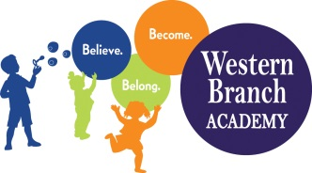 | WBA 2022-2023  PK 3 School Supply List  Teachers may request additional items

Backpack (Large enough to fit a folder)
Lunchbox (Daily)
Extra Set of Clothes (Please Label All Items with Child’s Name)
2 Packs of Baby Wipes
2 Boxes of Tissues
4 Pkgs. 5 oz. Cups
2 Boxes of Washable Markers (Primary Colors)
2 Bottles of Squeeze Glue
5 Pack of Glue Sticks
(Boys) 2 Boxes Gallon Ziploc Bags
(Girls) 2 Boxes Quart Ziploc Bags
2 Packages of Watercolors
1 Box of Crayons (24 Ct)
1 Package of Color Pencils
1 Package of Dry Erase Markers
2 Packages of Play- do
Smock or Old T-Shirt for art
1 Family Photo
1 Individual Photo (Wallet Size)
1 Folder with pockets
1 Container Lysol Wipes & 1 Lysol Spray
Nap Mat (Full Day Students Only) – Label with name (must be the plastic foldable nap mat)
Crib Sheet for Nap Mat (Full Day Students Only) - Label with name
Blanket for Nap (Full Day Students Only) - Label with name

