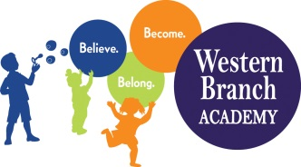 | WBA 2018-2019  PK 4 School Supply List  Teachers may request additional items at a later date
Tote bag/Small child backpack
Lunchbox (Daily)
Extra set of clothes (Please Label All Items with Child’s Name)
1 Pack of Page Protectors
4 Packages of Baby Wipes
2 Boxes of Tissues
4 Pkgs. 5 oz. Cups
1 Box Washable Markers (Primary Colors)
1 Box Fine Lined Washable Markers
15 Glue Sticks (White)
1 plastic folder with pockets
1 package Dry erase markers (fine point)
Hard pencil box
(Girls) 1 Play-Doh Package of 4
(Boys) White Index Cards (Sight Words)
(Boys) 1 Box Gallon Ziploc Bags
(Girls) 1 Box Snack Ziploc Bags
1 Package Watercolors
1 Family Photo
2 Photos of Child (Wallet Size)
1 White Binder (1 inch) – New students Only
1 Container Lysol Wipes
Nap Mat (Full Day Students Only) – Label with name
Crib Sheet for Nap Mat (Full Day Students Only)-Label with name
Blanket for Nap Time (Full Day Students Only)- Label with name

