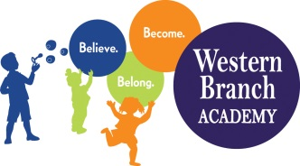 | WBA 2022-2023  PK 4 School Supply List  Teachers may request additional items at a later date
Backpack (Large enough to fit a folder)
Lunchbox (Daily) Labeled
Extra set of clothes (Please Label All Items with Child’s Name)
4 Packages of Baby Wipes
2 Boxes of Tissues
4 Pkgs. 5 oz. Cups
10 Pack of Glue Sticks
1 Box Washable Markers
1 folder with pockets (Labeled)
1 package Dry erase markers
Hard pencil box (Labeled)
2 Play-Doh Package of 4
1 Box of 24 Count Crayons
(Boys) 1 Box Gallon Ziploc Bags
(Girls) 1 Box Quart Ziploc Bags
3 Packages Watercolors
Old T-Shirt or Smock for Art
1 Family Photo
2 Photos of Child (Wallet Size)
1 Container Lysol Wipes and 1 Bottle of Lysol Spray
Nap Mat (Full Day Students Only) – Label with name
Crib Sheet for Nap Mat (Full Day Students Only)-Label with name
Blanket for Nap Time (Full Day Students Only) - Label with name

