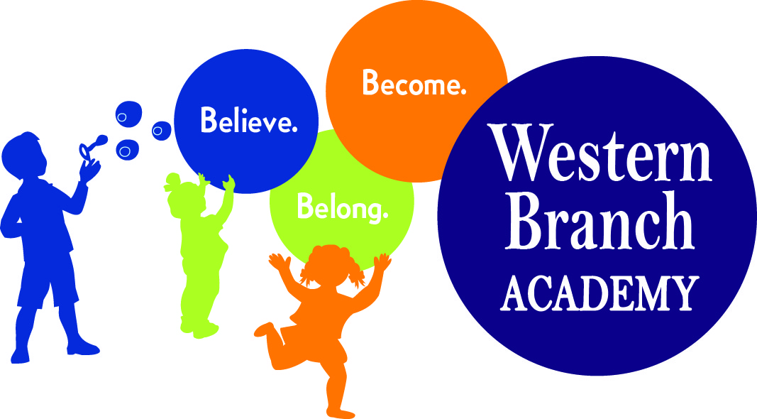 | SUMMER CAMP SUPPLY LIST (2019)

Swim suit-labeled
Beach towel-labeled
Water Play/Pool Shoes-labeled (flip flops, water shoes, Crocs, etc.)
Change of clothes-labeled in Ziploc bag
Swim diapers (children not potty-trained)
3 Packages of 5 oz. cups
2 Packages of baby wipes
1 Box tissues
Preschoolers – Small tote bag labeled with child’s name (big enough to put a folder in)
School Age – Backpack labeled with child’s name
Folder with Pockets -labeled
Nap Mat-labeled-Full day preschool students only
Crib sheet-labeled-Full day preschool students only
Blanket-labeled-Full day preschool students only
Lunchbox-labeled-children bring their lunch every day
(peanut/tree-nut free school)
1 Individual photo-Preschool only
*Sunscreen/Bug Spray Forms Filled out completely
Ziploc bags – Sandwich, quart and gallon size

